**Experiment**

The configuration we have used to simulate the proposed privacy-preserving candidate hiring architecture is an Intel i7-12700 processor clocked at a max frequency of 4900MHz and having 12 cores per socket.

The experiments were done with the consideration of experts performing their tasks parallelly, and then the average execution time per framework was calculated.

The experiment results have been represented in two different types. First, we compare all four frameworks with an encryption key size of 128 bits, and later, another comparison between frameworks 2, 3, and 4 has been done by varying the encryption key sizes for HE. Framework 1 has not been considered in the second type because it does not use any HE, so changing the encryption key size will not affect its average execution time; considering it in the second comparison will not be so fruitful; the result will be the same for all the test cases hence it has been dropped in second type comparison.

The experiments have been performed by varying the encryption key size in [128, 256, 512] bits. For 128, all four frameworks have been compared, and for 256 and 512-bit encryption, frameworks 2, 3, and 4 have been compared separately.

Both types of experiments are performed considering the following two settings after picking an encryption key size from the above-described list of different encryption key sizes. We try to study the average execution time for both types of experiments under the following two settings

1. By keeping the number of candidates constant and the number of experts variable.
2. Next, we varied the number of candidates, and the number of experts was kept constant.

**Experiment results for setting 1**

The number of experts has varied in [2,4,6,8,10], and the number of candidates has been kept at 20. The results comparing all four frameworks for the encryption of size 128-bit have been shown in Figure 1; in reality, 128-bit encryption is used only in frameworks 2, 3, and 4 because framework one doesn’t contain He it has no effect due to this encryption key size but to make a comparison of all four framework at a common stage it has been considered in 128-bit encryption key size., a comparison between average execution time and number of experts for the second, third, and fourth frameworks with encryption key sizes of 256 and 512 bits has been shown in Figure 2 and Figure 3, respectively. We have not considered Framework One in this comparison because it will have the same result as in the first case.

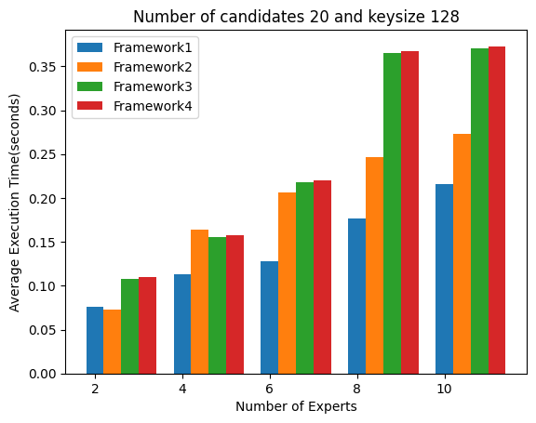

Figure 1: Comparing the average execution time of all frameworks with an encryption key size of 128-bit.

The results of Figure 1 show that the average execution times increase as the complexity of the framework increases. Our framework 1 is the very basic model and involves only a digital signature as the step where encryption is used, so the computational cost is also very low in comparison to other frameworks; it took about 0.26 seconds to declare the winner, but when we consider other frameworks they have higher complexity than framework 1, and it also effects on the average execution time for the same reason. If we see framework two, it takes about 0.32 seconds for ten experts under the same settings. When more complex steps containing SMPC and multiple steps of HE are introduced, such as in frameworks 3 and 4, the average execution times grow faster. For the third framework, the average execution time for ten experts was 0.332 seconds, and for the fourth framework, it took 0.349 seconds because of the introduction of the extra step of winner declaration by the employer in comparison to framework three. SMPC increases the communication overhead, affecting the computation overhead and thus impacting the overall average execution time. Framework 3 and Framework 4 require the SMPC to be done before declaring the winner, hence a greater communication overhead, which is the reason for the extra execution time in these two frameworks in comparison to the execution time of the first two frameworks. This difference in average execution time gets bigger as we increase the encryption key size. The encryption key size greatly impacts the average execution time because the complexity of the functions associated with, HE increases upon increasing the encryption key size. In Figure 2, with the encryption key size of 256-bit, framework two took 0.3490 seconds, and framework three had 0.450 seconds on ten experts, which is comparatively much more than what it was for the key size of 128-bit. Similarly, for framework four, it can be seen that average execution time becomes 0.460 seconds for ten experts as it has one more step than framework three, as discussed above. When we change the key size to 512 bits, the time complexity goes tremendously high, which is 0.783 seconds and 1.104 seconds for ten experts in Framework 2 and Framework 3, respectively, and for Framework 4, it becomes 1.1413 seconds. The same is shown in Figure 3. This growth in average execution times on increasing the encryption key size is due to the use of HE; as said earlier, encryption size affects the time complexity of the function associated with HE. Here, we have used the equation, Where Multiplication is performed on the ciphertexts to add the original inputs, but when we are using the 256-bit or 512-bit encryption key size, the ciphertext generated through the HE is equal to key size and performing multiplication to compute addition of the inputs on such ciphertexts creates a great computational overhead increasing the average execution time of framework three and framework 4.

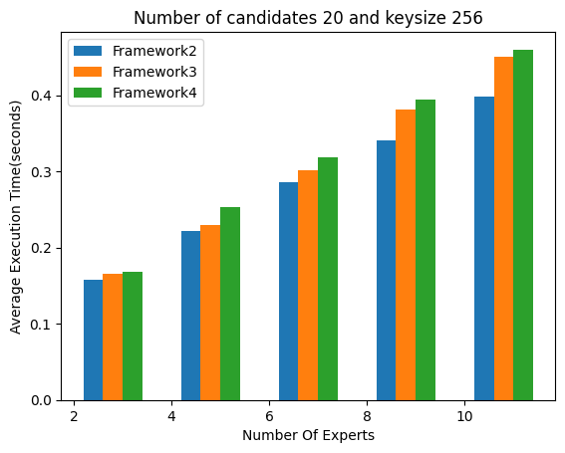

Figure 2: Comparison of the average execution times of frameworks 2,3 and 4 with an encryption key size of 256 bits

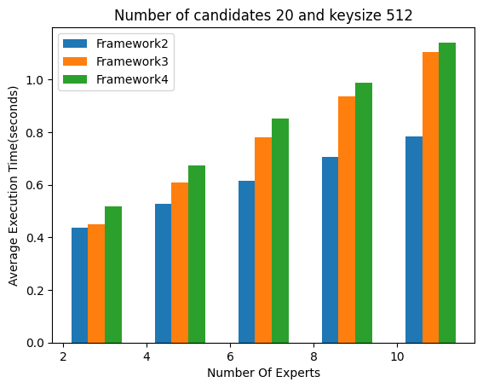

Figure 3: Comparison of the average execution times of frameworks 2, 3, and 4 with an encryption key size of 512 bits

**Experiment results for setting 2**

For the second setting, when we keep the number of experts constant at five and vary the number of candidates in [10, 20, 30, 40, 50], a similar time difference as of setting one between all four frameworks is found. Figure 4 shows the average execution time difference between all four frameworks with encryption key sizes of 128 bits, and Figure 5 and Figure 6 shows the execution times of frameworks 2, 3, and 4 for the encryption key sizes of 256 bits and 512 bits, respectively.

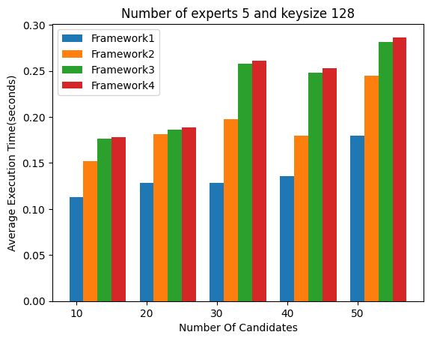

Fig 4: Comparing the average execution time of all frameworks with an encryption key size of 128-bit.

The comparison shows that our framework 1 takes an average execution time of 0.1529 for 50 candidates. Framework Two, framework three, and framework four are taking 0.2492 seconds, 0.2686 seconds, and 0.2755 seconds, respectively, for 50 candidates.

Similarly, when we start varying the key sizes from 128 bits to 256 and 512 bits, a huge change is found in frameworks two, three, and four because of the same reasons as are already discussed in setting 1. Average Execution times of the same are shown in Figure 5 and Figure 6. The average execution time for 256-bit encryption key size for frameworks two, three, and four is 0.39 seconds, 0.464 seconds, and 0.491 seconds, respectively, which increases rapidly on taking the encryption key size of 512 bits due to the same reasons discussed in setting one. Frameworks two, three, and four took 1.08, 1.33, and 1.46 seconds, respectively.

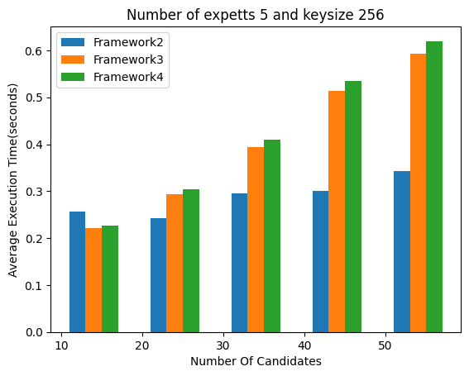

Figure 5: Comparison of the average execution times of frameworks 2, 3, and 4 with an encryption key size of 256 bits

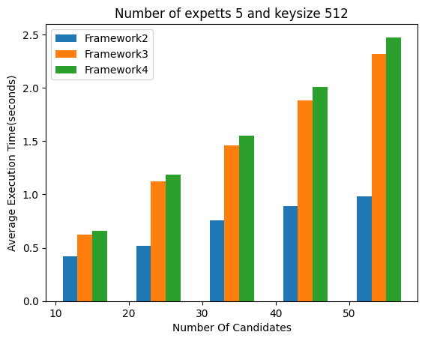

Figure 6: Comparison of the average execution time of frameworks 2, 3, and 4 with an encryption key size of 512 bits